**Lab 3**

2023101124 – Goni Anagha Room Number -- 125

2023101120 – Sachi Thonse Rao Table Number -- 43

**Aim:**

1)Using the HC-SR04 Ultrasonic sensor to get the distance value of the object kept in front and display the readings on the serial monitor.

2A) Using the bluetooth functionality of the ESP32 Dev module to communicate with the Serial Bluetooth Terminal on the Phone.

2B) To create a proximity notifier using the apparatus assembled in part 2A by entering the proximity threshold on the serial monitor of the phone. If the sensor distance reading is less than that of the threshold, light an LED notifying the user of a proximity alert.

3) Using the HC-SR04 Ultrasonic sensor to get the speed of the object in front of it upon command given through the serial monitor on phone.

**Hardware picture:**

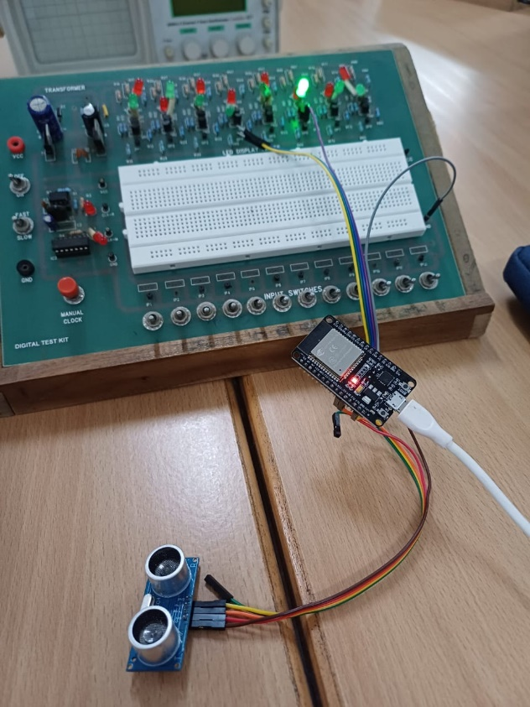 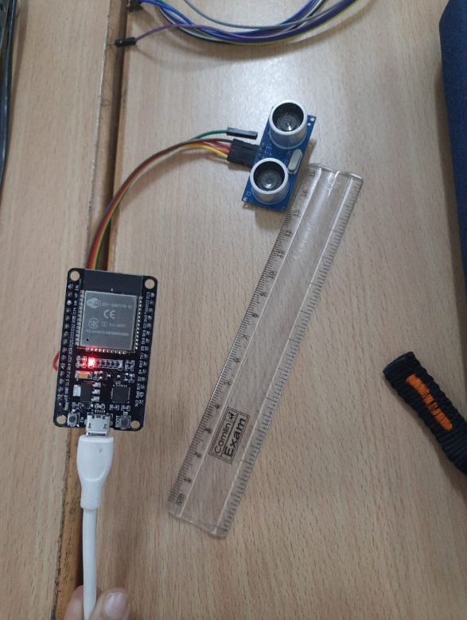

**Observations:**

Calibration of HC-SR04 Ultrasonic sensor: 1.51 to 400 cm

1. When the distance between the object and the sensor was less than 1.51 cm or greater than 400 cm then there was no output on the serial monitor. Time taken by the pulse to propagate was obtained through echo pin using pulseIn function in microseconds and then found the distance using basic math. The output distance was calculated in both cm and mm.

2A) we implemented the same experiment as in part 1 but printing the values on the Bluetooth terminal on phone.

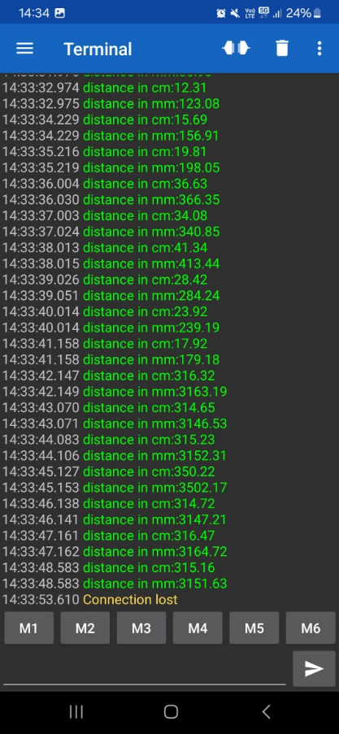

2B) We took threshold value as input from the user through Bluetooth terminal on the phone and used it to check whether the object was in vicinity of the sensor i.e, if the threshold > distance between object and sensor. LED was glowing when the object is in the vicinity.

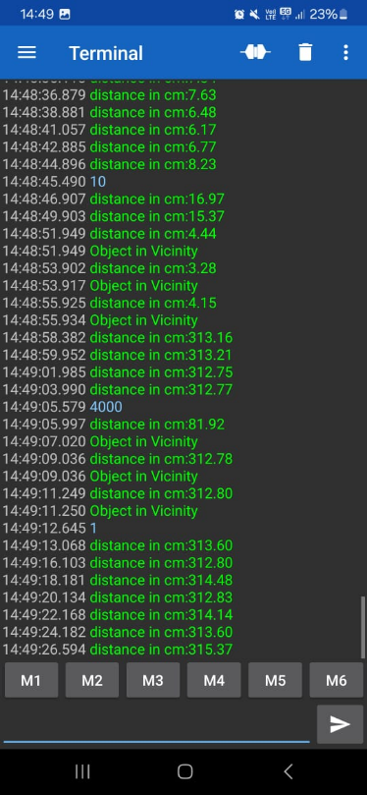

1. We found out the speed of the object speed=change in distance (m)/change in time (sec).

The speed was calculated only when a special character ‘s’ was given as input through Bluetooth terminal.

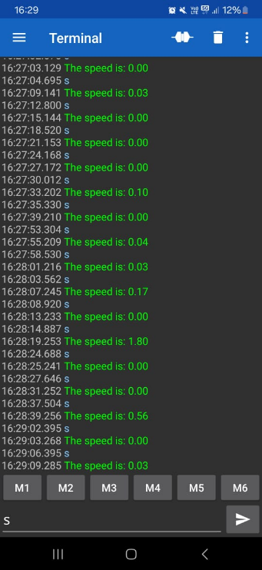

**Challenges faced during the experiment:**

We faced challenges while writing the code for the 3rd part.

**Conclusions:**

In this experiment, we calculated the distance between object and sensor through which we calibrated the sensor. We also found the speed of the object and determined whether any object lies within the given threshold or range with the help of an LED.